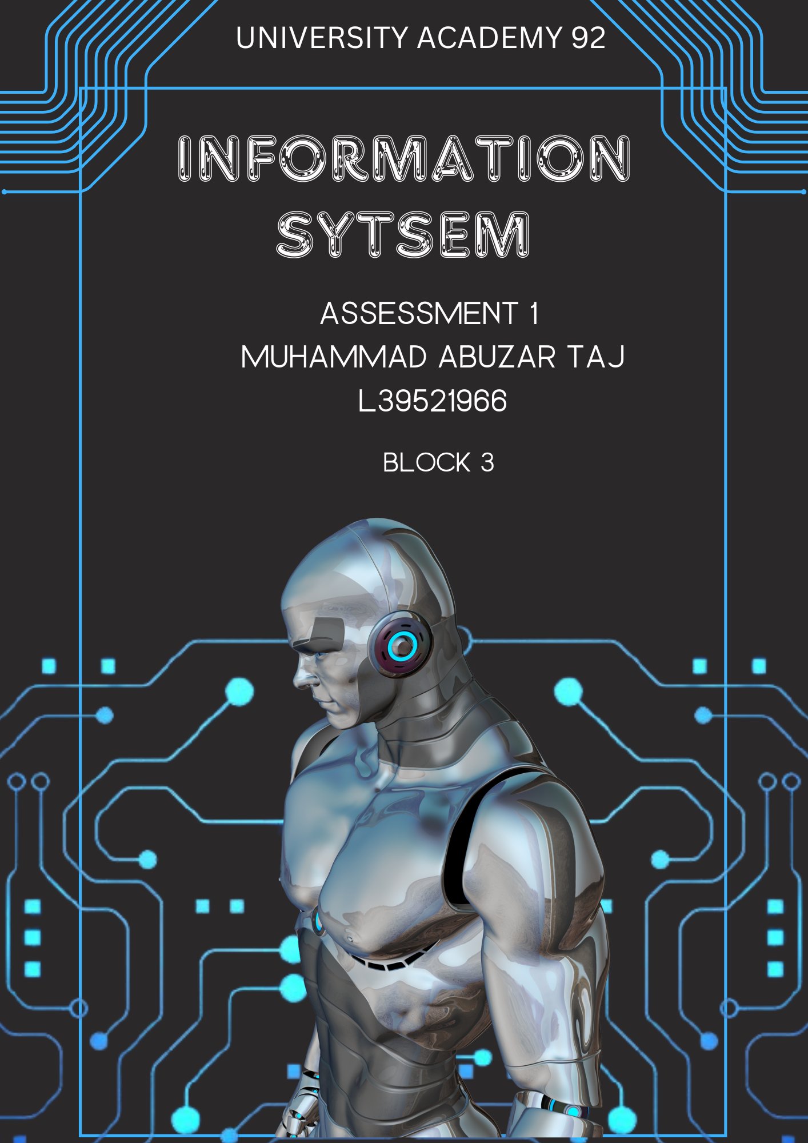

Contents

Introduction 3

Information System Needs at Leaf Village 3

Core Components of a Modern Information System 4

Types of Information Systems 5

System Development Lifecycle (SDLC) 6

Development Methodology and Justification 7

Requirements Analysis 7

Feasibility 8

SWOT Analysis: Current Manual System 8

SWOT Analysis: Proposed Digital System 9

Conclusion 10

References 11

Image References 12

Bibliography 13

Appendices 14

Appendix A - Evolution of Information Systems 14

Appendix B – Stakeholder Information System Table 15

Appendix C – Comparison of Development Methodologies 16

# Introduction

# In today’s educational landscape, managing information is vital for operational efficiency, meeting regulations, and supporting strategic goals. Leaf Village currently lacks a centralised system, hindering seamless service delivery across departments. This report explores how the organisation can adopt a structured information system to improve data accuracy and performance. It provides a critical analysis of system types suited to management levels, recommends a suitable development approach, and outlines stakeholder-driven requirements aligned with GDPR and ISO 27001 standards (Al-Hujran et al., 2023).

# Information System Needs at Leaf Village

As Leaf Village expands, a centralised information system is vital for strategic planning and daily efficiency. Currently, unstructured data handling leads to duplication and limits traceability, affecting performance and monitoring. Information needs vary by role: Principals need insights on course popularity, enrolment trends, and unpaid fees for decision making. Admin staff require real-time access to records, schedules, and room usage, while teachers and administrators depend on accurate student data for attendance, grading, and certificates(Laudon and Laudon, 2022). A centralised, role-based system would streamline operations, improve communication, and support compliance with data regulations .

# Core Components of a Modern Information System

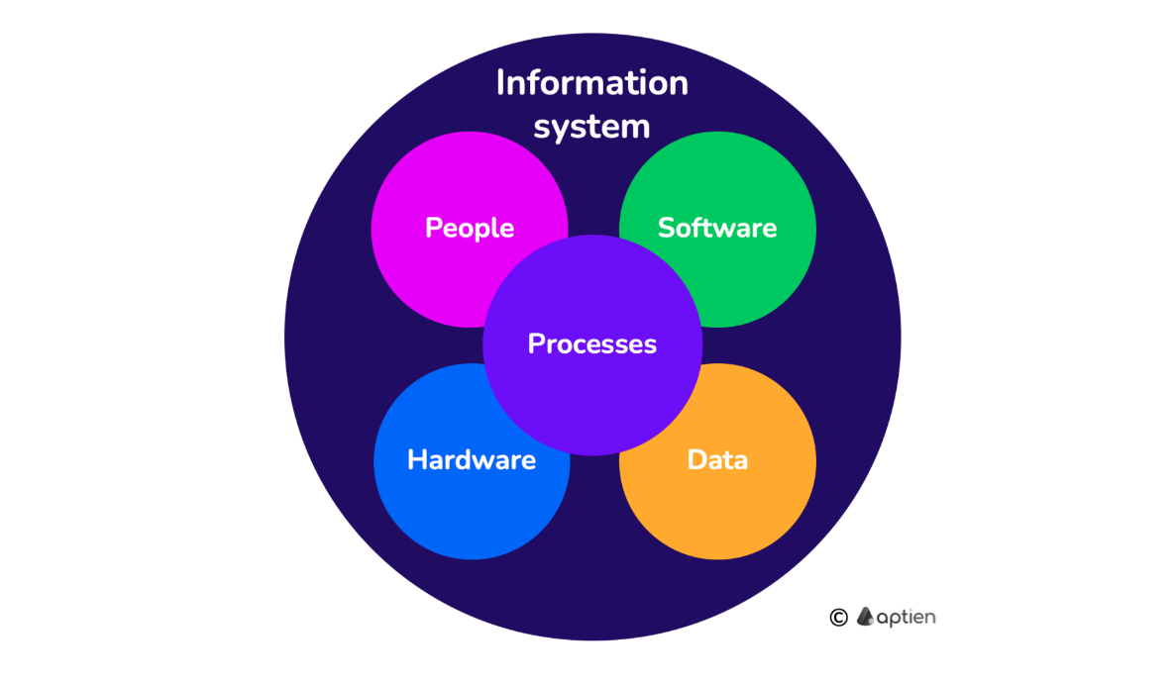

Figure 1: Core components of an information system (Aptien, 2024)

An information system consists of hardware, software, data, processes, and people working together to manage and share information (Aptien, 2024). . At Leaf Village, these components support enrolment, compliance, and communication. Hardware and software ensure secure access; data includes student records and attendance. Processes cover enrolment, fees, and reporting. People ,teachers, staff, leadership, finance, and parents interact through defined roles (e.g., attendance, payments, updates).

# Types of Information Systems

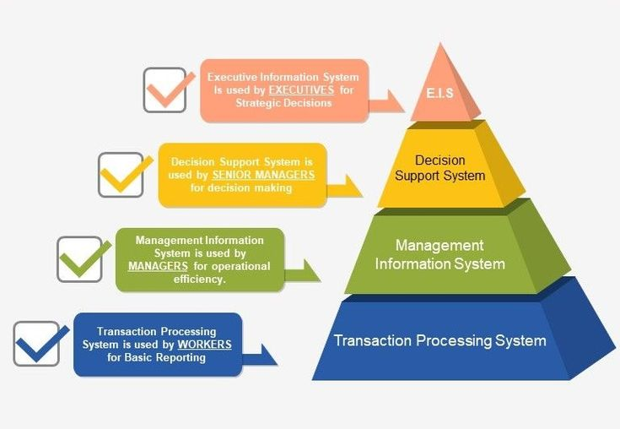

Figure 2:Roch, S. et al. (2022) IS types

Information systems are categorized by function and the management level they support (Board Infinity, 2021). Transaction Processing Systems (TPS) handle routine data operations, Management Information Systems (MIS) support planning and reporting, and Decision Support Systems (DSS) assist with complex decision-making. Other systems include Executive Support Systems (ESS) for senior-level overviews, Knowledge Management Systems (KMS) for sharing internal expertise,Office Automation Systems (OAS) for communication handling and Geographic Information Systems (GIS) for spatial data analysis (Laudon and Laudon, 2022).

Leaf Village needs a reliable combination of information systems to manage daily operations, support decision making, and enable future planning. The most suitable systems are Transaction Processing Systems (TPS), Management Information Systems (MIS), and Decision Support Systems (DSS) (Stair and Reynolds, 2021).

TPS handle enrolments, attendance, fee payments, and certificate generation, ensuring consistent, accurate data capture. MIS convert this data into useful reports, allowing admin staff and leaders to track patterns like enrolment trends and unpaid fees for better planning, compliance, and resource use. DSS support more complex decisions such as forecasting income, launching new courses, or adjusting staffing. OAS support communication handling (TechTarget, 2024).

Systems like Executive Support Systems (ESS), Knowledge Management Systems (KMS), and Geographic Information Systems (GIS) are less applicable here. ESS are designed for large corporations, KMS focus on sharing institutional knowledge, and GIS manages location-based data (Board Infinity, 2021). Which Leaf Village does not currently require.

# System Development Lifecycle (SDLC)

Figure 3: Unique Software Development (2025)

The System Development Lifecycle (SDLC) offers a structured process for developing and maintaining effective information systems (CloudDefense, 2021). It begins with planning and a feasibility study to determine if the system is viable and aligns with organisational needs.

Next is the requirements and analysis phase, where user needs and data requirements are identified. The design phase then outlines the system’s structure, including the database, interface, and workflows. Development follows, involving coding and building the system, while testing ensures functionality, security, and compliance with regulations.

At Leaf Village, applying SDLC ensures legal standards like GDPR (Xygeni, 2025) are addressed early. The final stages deployment and maintenance help the system run smoothly and adapt over time, supporting long-term success.

# Development Methodology and Justification

Agile approach is recommended for developing Leaf Village’s information system. It is an iterative, flexible approach focused on continuous improvement. Though often used in teams, it suits solo development by breaking tasks into manageable cycles (Pressman and Maxim, 2020).

Agile allows key features like attendance tracking or secure access to be prioritised. This approach supports adaptability, enabling the system to respond to stakeholder feedback and evolving compliance needs. Role-based access and communication features can be refined after initial testing.

In contrast, Waterfall is rigid and linear, lacking flexibility for mid-project changes. RAD focuses on speed over stability, risking poor data protection and long-term maintenance issues.

Overall, Agile provides the flexibility and control necessary for a reliable and adaptable system build.

# Requirements Analysis

The proposed information system must meet the needs of Leaf Village’s stakeholders, including students, staff, finance officers, leadership, and parents. Each group requires role-based access, tailored features, and relevant data views. System mapping is shown in Appendix B.

Functionally, the system must handle enrolment, fee tracking, attendance, scheduling, report generation, and certificate issuance. Non-functional requirements include usability, data integrity, secure login, and scalability for future growth.

The system must follow GDPR and ISO 27001, while addressing ethical, social, and professional obligations. According to Laudon and Laudon (2022), well-implemented systems can reduce administrative workload by up to **75%** through automation and streamlined access. ISO 27001 provides risk management through access controls, encryption, and audit logs to safeguard sensitive student and financial data (Yehuda, 2018). The California Consumer Privacy Act (CCPA), a globally influential law, adds requirements for transparency and consumer data rights (Greenleaf, 2020). Together, these standards ensure Leaf Village securely collects, stores, audits, and shares personal data while meeting all regulatory obligations.

# Feasibility

The existing manual system is easy to use but inefficient, as it depends on paper records that slow down processes and risk data loss. A basic risk analysis highlights threats like data loss, inefficiency, and limited traceability. A digital system offers automated tasks, accurate record-keeping, and better communication between users. While some staff training is required, the system supports future scalability, enhances parental engagement, and ensures secure access. It also improves compliance with GDPR and protects sensitive data. Overall, (Beram, 2024) the benefits clearly outweigh the short-term challenges, and the system can be developed and implemented efficiently within a 3 - 4 week Agile cycle.

## SWOT Analysis: Current Manual System

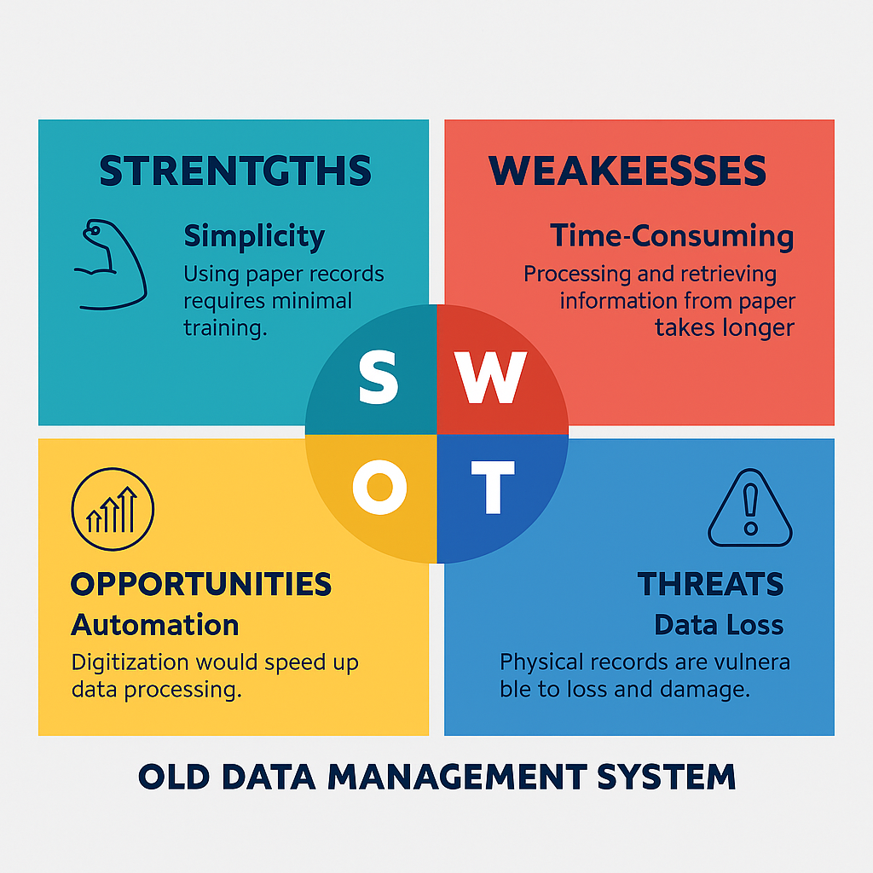

Figure 4:SWOT analysis current system

## SWOT Analysis: Proposed Digital System

Figure 5: New system

# Conclusion

This report has examined the current inefficiencies in Leaf Village’s manual data management and proposed a structured, centralized information system tailored to organizational and stakeholder needs. Developed from the perspective of an analyst working within an Agile-oriented team, the system ensures flexibility, legal compliance, and long-term sustainability through the application of SDLC and Agile methodology. Key system types TPS, MIS, and DSS have been critically selected to align with the operational, managerial, and strategic levels within the organization. The functional and non-functional requirements, supported by GDPR, ISO 27001, and CCPA standards, ensure secure and ethical data use. With visual analysis and system mapping, this report demonstrates that implementation is not only technically feasible, but also strategically essential for improving communication, accountability, and data-driven decision making across Leaf Village.

# References

Al-Hujran, O., Al-Lozi, E. and Al-Debei, M.M. (2023) ‘Information Systems Planning in the Digital Era: Revisiting the Role of Strategic Alignment in Educational Institutions’, *Information Systems Frontiers*, 25(1), pp. 101–120.

Beram, S**.** (2024) *How to Conduct a Feasibility Study: Template and Examples*. *LogRocket Blog*. Available at: <https://blog.logrocket.com/product-management/feasibility-study-how-to-template-examples/> (Accessed: 25 June 2025).

Board Infinity (2021) *What are the Types of Information Systems?* [online]. Board Infinity. Available at: <https://discuss.boardinfinity.com/t/what-are-the-types-of-information-systems/10932> (Accessed: 1 July 2025).

IBM (2024) *What is Agile Software Development?* Available at: <https://www.ibm.com/topics/agile-software-development>

Laudon, K.C. and Laudon, J.P**.** (2022) *Management Information Systems: Managing the Digital Firm*. 17th edn. Harlow: Pearson Education.

Pressman, R.S. and Maxim, B.R. (2020) *Software Engineering: A Practitioner’s Approach*. 9th edn. New York: McGraw-Hill Education.

Stair, R. and Reynolds, G. (2021) *Principles of Information Systems*. 14th edn. Boston: Cengage Learning.

TechTarget (2024) *What is a decision support system (DSS)?* [online] TechTarget. Available at: <https://www.techtarget.com/searchcio/definition/decision-support-system-DSS> (Accessed: 1 July 2025).

Xygeni (2025) *What are the Phases of the Software Development Life Cycle?* [blog] Xygeni. Available at: <https://xygeni.io/blog/what-are-the-phases-of-software-development-life-cycle/> (Accessed: 1 July 2025).

Yehuda, Y**.** (2018) ‘5 Ways to Make Your Database GDPR-Compliant’, *DZone*. Available at: <https://dzone.com/articles/5-ways-to-make-your-database-gdpr-compliant> (Accessed: 25 June 2025).

# Image References

Aptien (2024) *What is an Information System?* Available at: <https://aptien.com/en/kb/articles/what-is-enterprise-information-system> (Accessed: 25 June 2025).

Roch, S. et al. (2022) 11.4. Information Systems. *ecampusontario.pressbooks.pub*.

SlideTeam (n.d.) *RAD vs Other Software: Rapid Application Development vs Waterfall vs Agile*. Available at: <https://www.slideteam.net/rad-vs-other-software-rapid-application-development-vs-waterfall-vs-agile.html> (Accessed: 25 June 2025)

Unique Software Development (2025) *The Software Development Life Cycle (SDLC): 7 Phases and Models*. Available at: <https://uniquesoftwaredev.com/the-software-development-life-cycle-sdlc-7-phases-and-models/> (Accessed: 25 June 2025).

# Bibliography

GeeksforGeeks (2024) *5 Most Commonly Used Software Development Methodologies*. Available at: <https://www.geeksforgeeks.org/5-most-commonly-used-software-development-methodologies/> (Accessed: 25 June 2025).

Greenleaf, G. (2020) ‘Global Data Privacy Laws 2020: Despite COVID Delays, 145 Laws Show GDPR Dominance’, *Privacy Laws & Business International Report*, (166), pp. 1–13. Available at: <https://papers.ssrn.com/sol3/papers.cfm?abstract_id=3644607> (Accessed: 26 June 2025).

Kavlakoglu, E**.** (2020) *Agile vs Waterfall*. Available at: <https://www.ibm.com/think/topics/agile-vs-waterfall?mhsrc=ibmsearch_a&mhq=agile%20> (Accessed: 25 June 2025).

Open University (2023) *Quick Guide to Harvard Referencing*. Available at: <https://www.open.ac.uk/library/referencing-and-plagiarism/quick-guide-to-harvard-referencing-cite-them-right> (Accessed: 25 June 2025).

# Appendices

## Appendix A - Evolution of Information Systems

Timeline showing the evolution of information technologies and their role in business process transformation and automation.

Figure 6: ResearchGate (2018). Evolution of Information Technologies

## Appendix B – Stakeholder Information System Table

This table outlines how different stakeholder groups within Leaf Village interact with the information system and which system types support their needs.

Figure 7: Stakeholder needs and matching information systems )

## Appendix C – Comparison of Development Methodologies

